Raksha Bandhan Celebration 2019

Date: 10 August, 2019
Audience: Faculty Members
Venue: IITM Auditorium

On 10th of August, IITM group of Institutions has celebrated Raksha Bandhan festival with intense excitement. The representatives of Brahmakumaris graced the occasion and highlighted the spiritual meaning of Raksha Bandhan. They also shared their thoughts about how to protect and maintain the purity of soul. The sisters from BrahamaKumaris also explained that Rakshan Bandhan festival is not only between brothers and sisters but also with our own self and inner belief.
The session proceeded with the meditation which was then followed by Rakhi celebration and sweets distribution among all the faculty members.
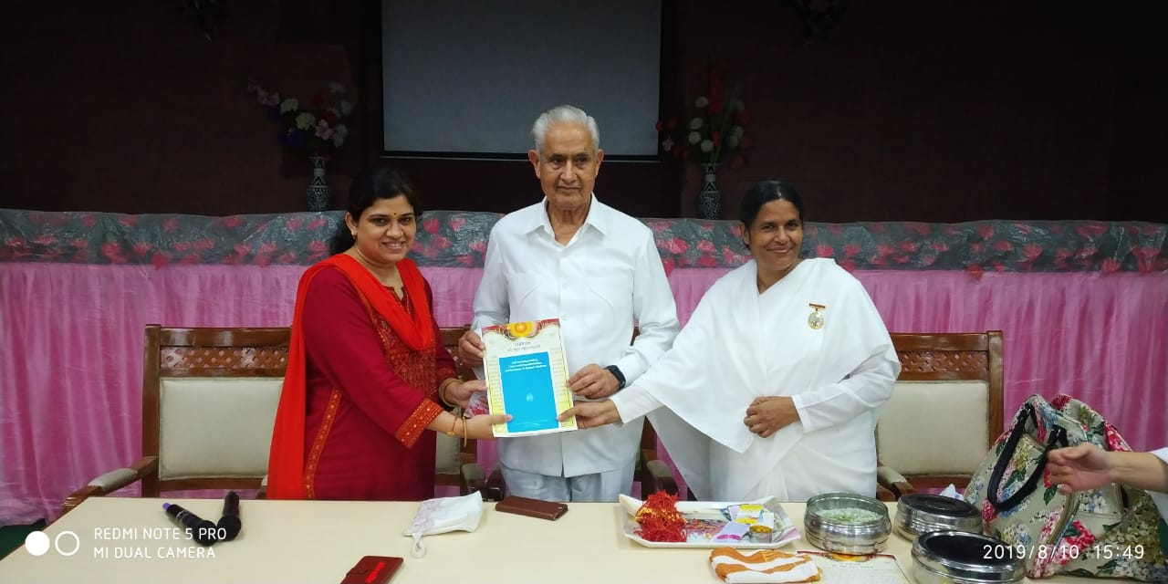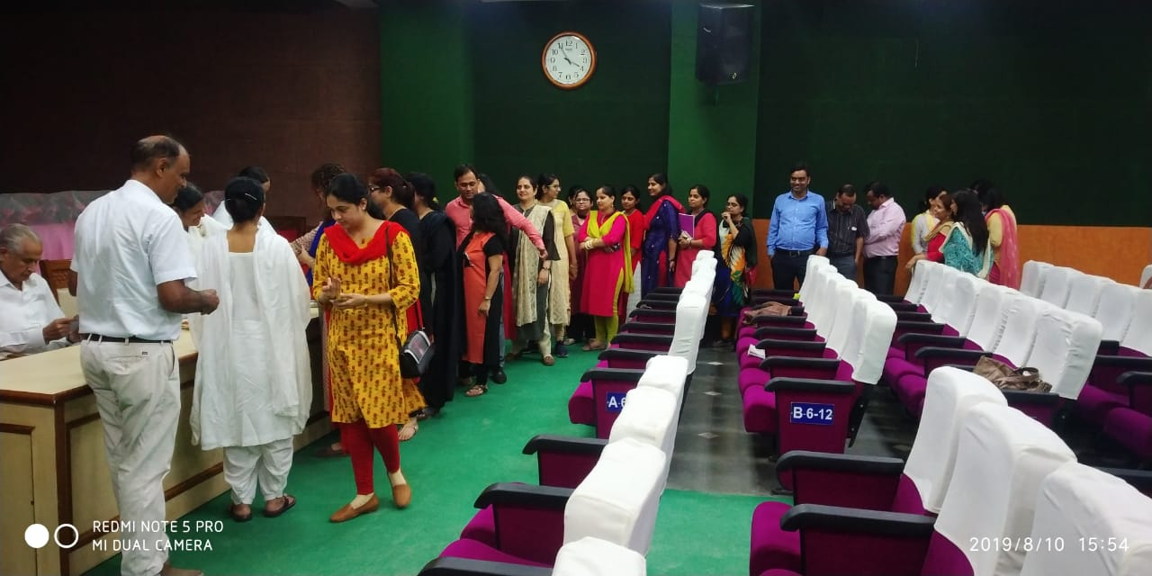

Submitted By: Ms. Gunjan

CHARITY DRIVE
Date: 16th-23rd October 2019
Venue: College premise and Centre of Shresth Bharat Foundation Dwarka
Target Audience: Faculties & Staff, Students
Event Coordinator: Dr. Monica Sharma
“The simplest acts of kindness are by far more powerful than a thousand heads bowing in prayer.” ― Mahatma Gandhi
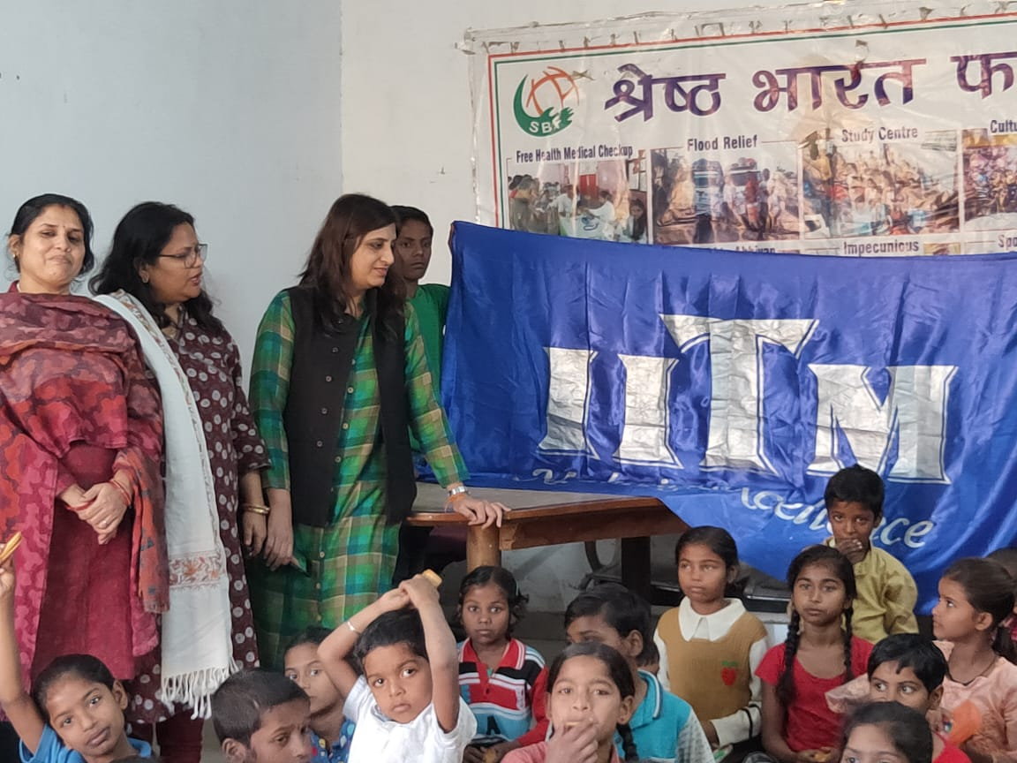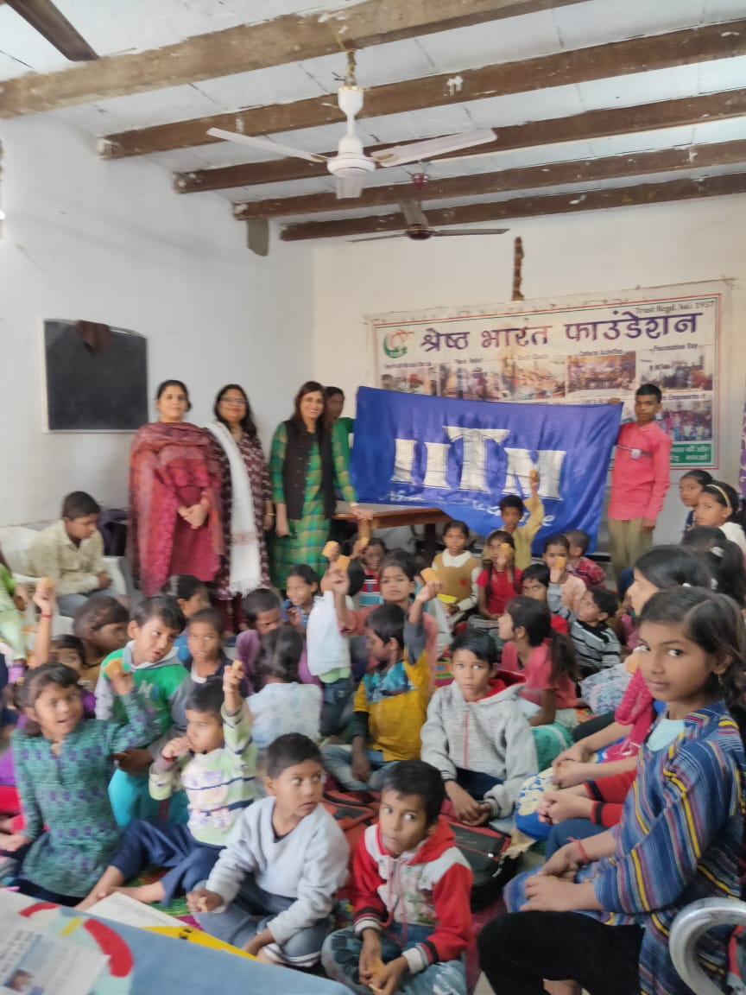

“One week Charity Drive ” was organised at IITM College, Janakpuri from 16th -23rd October, 2019. All the faculty, staff members and students generously contributed items such as ready to eat items (Biscuits, chips, packed bakery items etc.), Baby food, Milk Powder, Cleaning Items (Toothbrush, Toothpaste, Soaps, Washing Powder, Detergent, and Bleaching Powder), New and Used Clothes (in good condition) and sanitary napkins, Bed sheets & Blankets, Slippers etc. 250 students participated in the event.
The items were donated to Shreshtha Bharat Foundation, Dwarka.

Dr.Monica Sharma
Head,DAYITVA

Ref No:- IITM(JP)-IPU/Notice/2019/1079 Date: 14-10-2019

Notice No:1079
CHARITY DRIVE BY “DAYITVA”
“The simplest acts of kindness are by far more powerful than a thousand heads bowing in prayer.” ― Mahatma Gandhi
All the faculty, staff members and students are hereby informed that the “DAYITVA” Club of institute is running a charity drive for one week i.e. from 16th October 2019 to 23rd October 2019. In this regard all are requested to contribute generously for the noble cause. All donations will go to AIIMS Nurses Union, Delhi. We can contribute anything to everything such as ready to eat items (Biscuits, chips, packed bakery items etc.), Baby food, Milk Powder, Cleaning Items (Toothbrush, Toothpaste, Soaps, Washing Powder, Detergent, and Bleaching Powder), New and Used Clothes (in good condition) and sanitary napkins, Bed sheets & Blankets, Slippers etc. (Note: Please put all the items you wish to donate in the boxes kept at the reception)
Student Coordinators
Rijo Varghese 8802108678
Rachit Malhotra 8860122805

CSR Activity
Date: 25th Oct, 2019
Target Audience: IITM students & Faculty members
Venue: IITM campus
A CSR activity was organized on 25th Oct, 2019 to make students learn about the basic concepts of CSR. The students of BBA (second year) took part in this activity. This activity highlighted the concept that business organizations should take an active interest in wider social issues, rather than just on profit margins. A selling stall was organized by students where all those products were kept, which were purchased from a social welfare society named “The New Learning Heights School” Dwarka and from NGO named “Literacy India”, Gurgaon. The revenue generated from this activity along with hundred packets of biscuits and some blankets were donated to “The New Learning Heights School” i.e. school and remedial centre for specially-abled children. This initiative was taken to inculcate social skills among students to make them socially responsible towards community. It was a great learning experience for all the students.
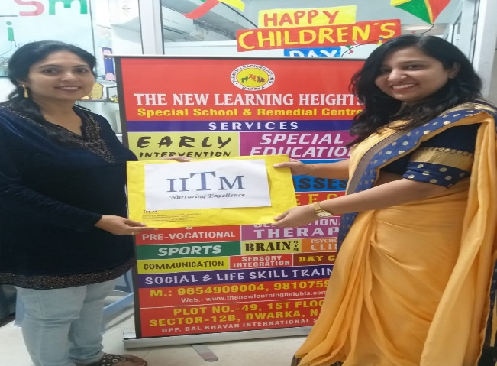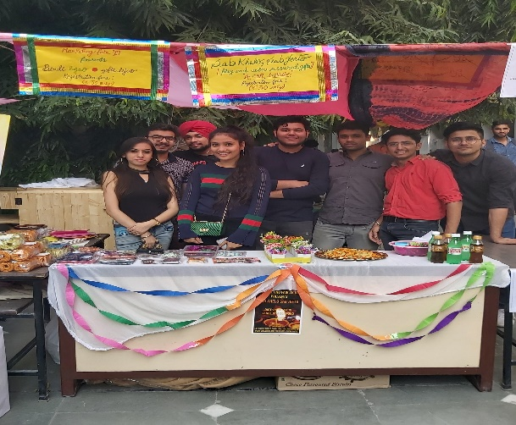
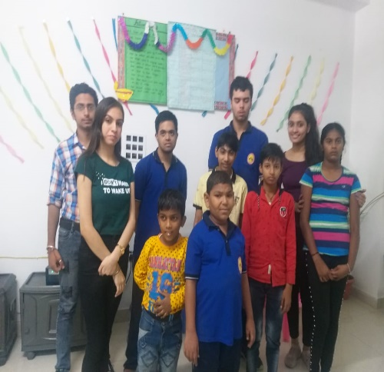
Submitted By: Dr. Shefali

Ref No:- IITM(JP)-IPU/Notice/2019/1024 Date: 11-03-2019
Notice No: 1024

BLOOD DONATION CAMP
This is to inform all the students of BBA, BCA, and B.Com (H) that “BLOOD DONATION CAMP” is being organized by “DAYITVA” in collaboration with National Thalassemia Welfare Society on 14 th March, 2019 at 10:00 am in Seminar Hall (Basement). The donor will get a certificate, refreshment, memento and a donor card which is valid for one year and is entitled for one unit blood replacement in all the government blood banks in Delhi.
Important Guidelines for Donors:
1. Donors are requested to drink plenty of water before and after donating Blood. 2. Please have breakfast or eat something solid before donating blood. It must not be more than 2 hrs empty stomach.

Faculty Coordinators: Dr. Monica Sharma Ms. Payal Jha

INSTITUTE OF INNOVATION IN TECHNOLOGY & MANAGEMENT
Blood Donation Camp
w.r.t Notice No: 1024

Date: 14-03-2020
Event: Blood Donation Camp
Target Audience: BBA, BCOM, BCA I & II Year Student
Venue: IINTM Basement
Event Coordinator: Dr. Monica Sharma, Ms. Payal Jha
BLOOD DONATION CAMP” was being organized by “DAYITVA” in collaboration with National Thalassemia Welfare Society on 14 th March, 2019 at 10:00 am in Seminar Hall (Basement). The donor will get a certificate, refreshment, memento and a donor card which is valid for one year and is entitled for one unit blood replacement in all the government blood banks in DelhWinner of the Competition:
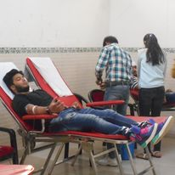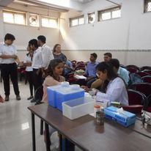

Submitted By: Prof.(Dr.) Vani Vasakarla
Dr. Monica Sharma Director

Ref No:- IITM(JP)-IPU/Notice/2020/1110 Date: 08-02-2020
Notice No: 1110
Parliament Visit on 14th Feb 2020
All the students of BBA, B.COM(Hons.) 1st and 2nd year are hereby informed that the Institute is organizing Parliament visit on 14th February 2020.
Interested students can give their name to their respective mentors.
Note: On the day of the visit all students must report at the college at 8 AM in formals.

Awareness Constitutional Framework & Duties
Visit to Parliament
w.r.t Notice No: 1110
Date: 14/02/2020
Event: Trip to Parliament
Target Audience: BBA, BCOM I & II Year Student
Venue: India Gate, Parliament
Event Coordinator: Dr. Mohita Mathur, Dr. Monica Sharma, Ms. Ankita & Dr. Malini
For a management student it is important to understand the structure of an organization , how it functions and how decisions are made. Same is expected to understand about the nation also. It is important for the students to understand how the political system of our nation works so the Institute arranged Parliament Visit for the students of First and Second year BBA, BCOM & BCA. The students understood the decision making process of the Indian political system and how the parliament works and how the Bills are passed.
It was a very special experience for the students as well as for the accompanying faculty.
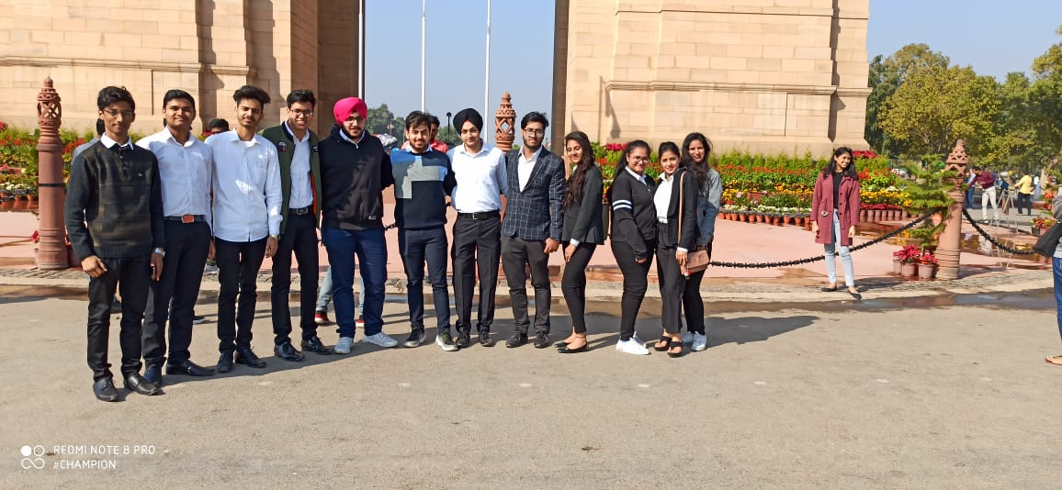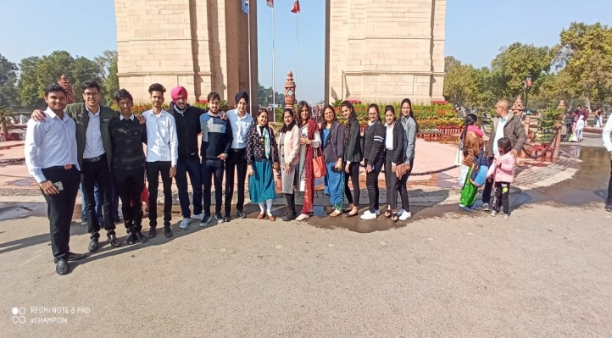
Visiting the parliament makes the student learn the process and understand the functionality of the Indian political system.
Submitted By: Prof.(Dr.) Vani Vasakarla
Dr. Mohita Mathur Director

