INSTITUTE OF INNOVATION IN TECHNOLOGY & MANAGEMENT
Global Talent Track Workshop

Date: 29th Aug 2017-30th Aug 2017
Organized For: BCA III and BCA V Semester Students
Faculty Coordinator: Mr. Pramod Soni and Ms. Harsh Arora
Global Talent Track (GTT) conducted 2-days workshop for the students of BCA III and BCA V semesters on 29th -30th Aug 2017. This workshop was conducted simultaneously in three rooms (Seminar Room, Room no 311 and 312). Room no 311 was allotted to BCA III M1 and M2 students and Room no 312 for BCA III E1 and E2 students. BCA V students were allotted seminar room. Timings for the workshop were 9:00 am to 5:00 pm. All students were formally dressed. The aim of the workshop was to improve the soft skills. The focus was on resume writing, participation in group discussions, conduct during interviews and improving communication skills. This workshop would help students to prepare themselves for facing the interviews.

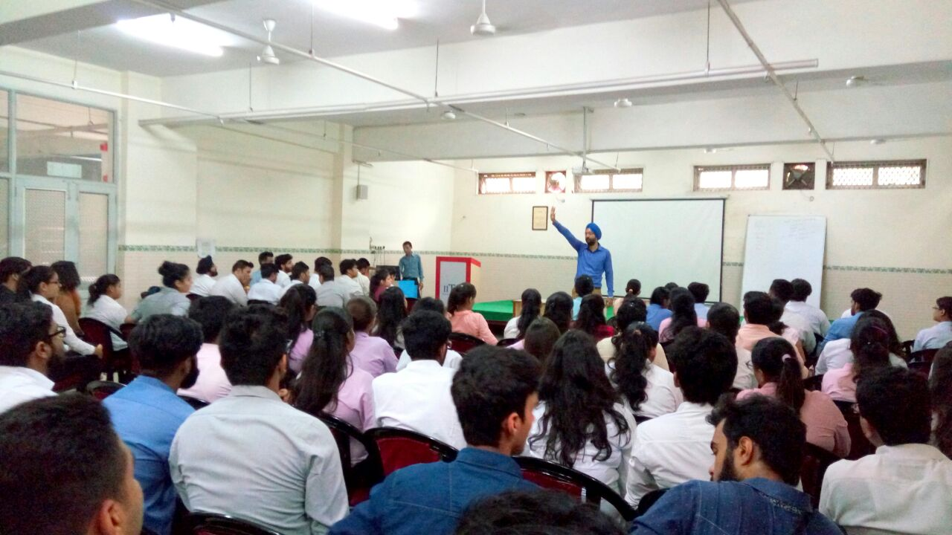

Submitted By: Prof.(Dr.) C P Chawla
Ms. Pooja Saigal Director

