Institute of Innovation in Technology & Management
Workshop on Dos and Don’ts of Group Discussion

Date: 30th August, 2017.
Organized for: IINTM Students
Resource Person: Mr. Amit Poddar

On 30th August, 2017 a workshop was organized for BBA and BCom(H) V semester students on Dos and Don’ts of Group Discussion. Mr. Amit Poddar, chief knowlege expert, TIME was the key resource person of the workshop. He discussed the importance of Group discussion skills in the recent time. He highlighted the four most important elements of group discussion i.e. content, communication skills (speaking, listening, modulation), corporate behaviour and leadership qualities. He advised the students to increase their knowledge base and word power to achieve success in a group discussion. At the end of the workshop he conducted a group discussion with the students on the topic “Is Gandhigiri relevant in today’s scenario”. It was a great learning experience for the students.

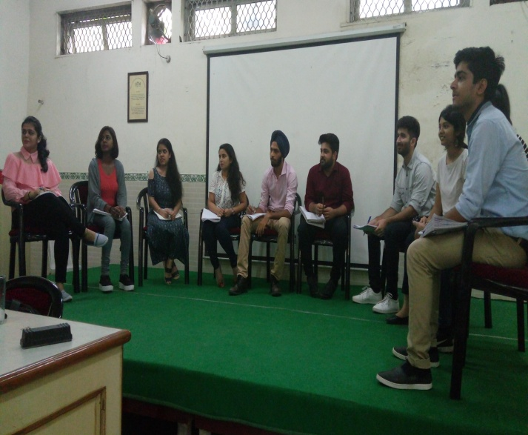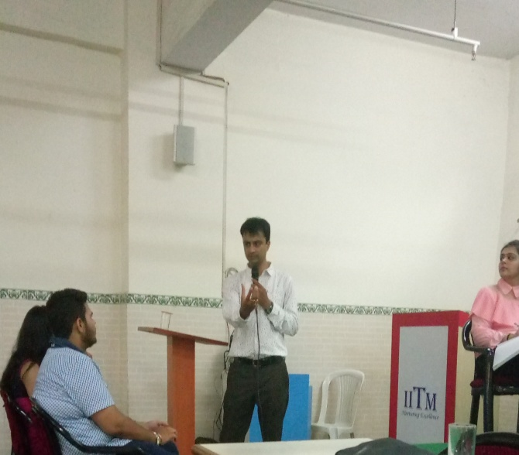

Report prepared by: Prof. (Dr.) C.P. Chawla
Dr. Renu Sharma Director, IINTM

