INSTITUTE OF INNOVATION IN TECHNOLOGY & MANAGEMENT
Orientation Day for Batch 2017-2020

Date: 1st August, 2017
Target Audience: New students
An orientation programme was organized by IITM-JP on 1st August, 2017, for newly admitted students of batch 2017-2020. The main objective of the programme was to enhance the awareness of the students about the institute. The programme was started with auspicious lighting of lamp by the Director Prof. C. P. Chawla and some of the senior and meritorious students of the college. It is followed with Saraswati Vandana. Thereafter, the Director of the Institute welcomed the new students and enlightened them. Dr. Monika Kulshreshtha, HOD, Management, briefed the new students about the rules and regulations of the institute.
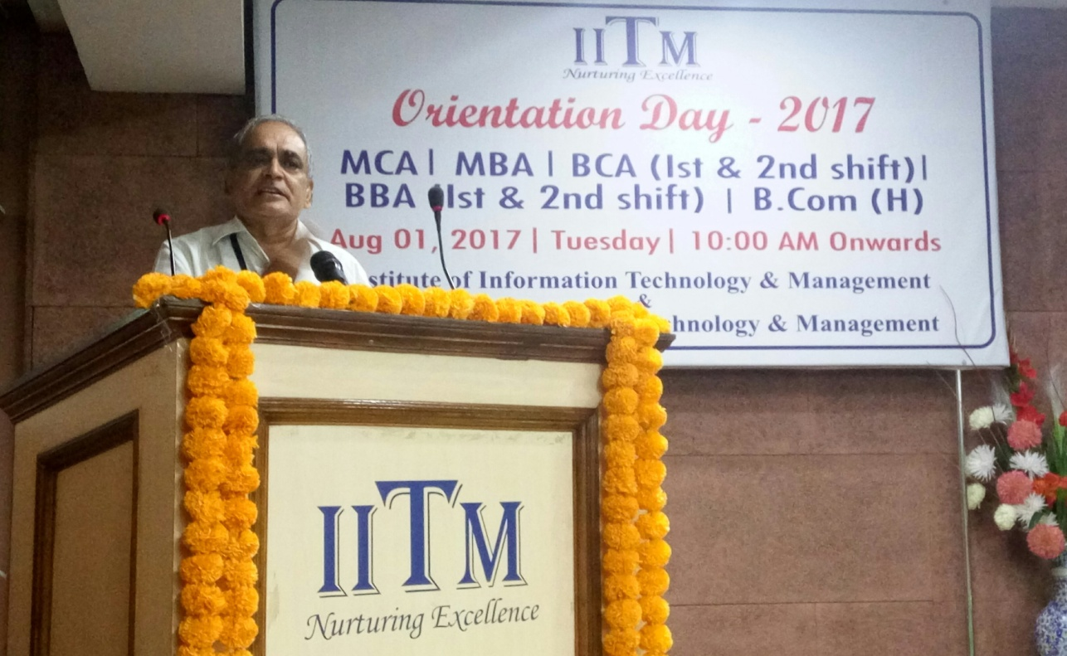

Submitted By: Prof.(Dr.) C P Chawla
Mr Deepak Trivedi Director

