INSTITUTE OF INNOVATION IN TECHNOLOGY & MANAGEMENT
Just A Minute Competition Event at College organized by “VYUDIT” debate society
(wrt Notice No 821-L)
Date: 8th September 2017
Target Audience: All Students of BBA/BCA/B.Com
Event Coordinator: Dr. Sarmishtha Sarma , Ms. Manpreet Kaur
Student coordinator : student members of ‘VYUDIT’
IINTM’s Debate society “VYUDIT” organized an event “Just a Minute(JAM)”, a speaking competition on 08th September 2017.
Highlight of the event were creative and confident messages conveyed by students on the topics allotted to them. The topics included recent happenings like GST, Indian Army, BRICS summit and general social topics like water, poverty, Being Human and importance of traffic rule.The student coordinators planned the event of: JAM Competition for all the students of Bcom (H), BBA and BCA students in the College itself. In all 28 students participated in the event.
The duration of the event was of 2 hours and the students enthusiastically participated and showed their creative verbal talents. Each of the winner was awarded a certificate
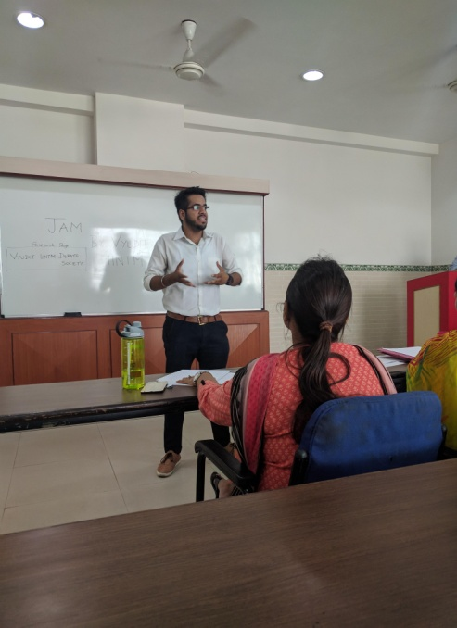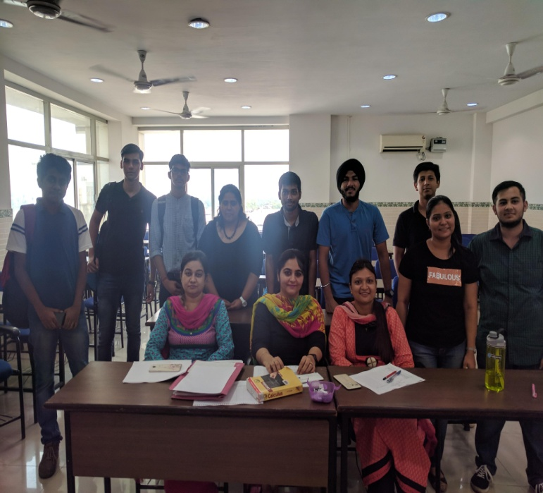

Submitted By: Prof.(Dr.) C P Chawla
Ms. Manpreet Kaur Bhatia Director General

