INSTITUTE OF INNOVATION IN TECHNOLOGY & MANAGEMENT
24 HOURS-HACKATHON 2017 AT IITM ORGANIZED BY “SRIJAN E-CELL”
Date: September 9-10, 2017
Target Audience: Students
Event Coordinator: Ms. Suruchi Sinha
Student Coordinators: Ranajoy Dutta, Mehak Twakley, Garvit, Shivangi Kharbanda, Anant Kaushik
Challengers is a technical team developed by Srijan Incubation Center, IINTM, during the summer training session, organized by the college in June 2017. Team Challengers made a system which is programmed using Python language.
HACKATHON, a 24 hour coding competition, was organized by team Challengers of Srijan Incubation Centre, IINTM. It is a Real-Time Programming-Problems Based event, which started at 9:00 AM on 9th September 2017 and ended at 8:59 AM on 10th September 2017. Hackathon provided opportunity for students, not only from our college, but also for 100+ students from over 47 colleges around 16 states of the country, to participate in the very first coding competition organized in the college. Later, due to requests from many of the participants we extended the Hackathon for 3 more hours.
Students from 47 colleges across the nation participated in the event. Colleges like IIT Delhi, DTU, Maharja Surajmal Institute, and many others took part with the eagerness to learn. Participants from other universities were also invited to the college, to join the troubleshooting session from 9:00 AM to 3:30 PM on September 9, after which, they were allowed to complete the rest of the problems, virtually, from their home.
This session, organized at the college, handled several issues like server error, CPU scheduling, Transaction Control, etc. It was a wonderful experience to conduct HACKATHON for the very first time and there are many more, bigger and better, waiting in the pipeline.
Results will be declared soon, as the evaluation process has already started and we will be awarding wonderful prizes to the winners and tokens of appreciation to all. Thank you everyone for your support.

Name of all the students who organized the event, with Roll Number and Stream:
NAME | ROLL NO. | STREAM | SEM (M/E)
Ranajoy Dutta | 05990302016 | BCA | III M1
Anant Kaushik | 00790302016 | BCA | III M1
Mehak Tawakley | 04090302016 | BCA | III M1
Himanshi Kohli | 02790302016 | BCA | III M1
Shivangi Kharbanda | 07090302016 | BCA | III M2
Garvit Singh | 03024402016 | BCA | III E1
Nishant Nirmal | ODL/16/401/0110 | BCA | III

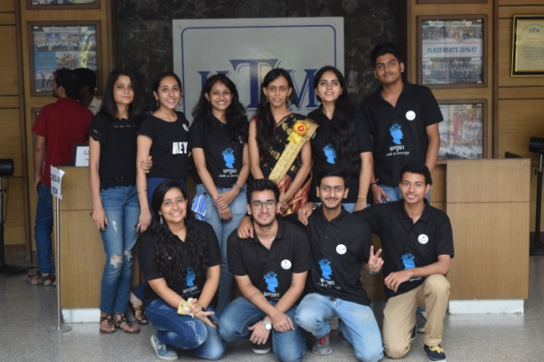

Submitted By: Prof. (Dr.) C P Chawla
Ms. Suruchi Sinha Director

