Institute of Innovation in Technology & Management
Skill Enhancement Training on Digital Marketing

Date: 15th June to 31st July, 2017.
Organized for: BBA IV (Batch: 2015-2018)
Resource Person: Mr. Shivam Ahuja (Co-founder, Skill Circle, Edutrain Consultants Private Limited)
To improve the employability of the students, eight weeks skill enhancement training on Digital Marketing was organized for the students of BBA IV semester of Institute of Innovation in Technology & Management by Edutrain Consultants Private Limited. The training was conducted from 15th June to 31st July, 2017. In this training, all the important aspects of Digital Marketing including SEO, Google Adwords, Google Adsense, Affiliate marketing, Email marketing, Lead generation, website creation and strategy, professional blogging and social media marketing were covered. The students were given projects in teams.
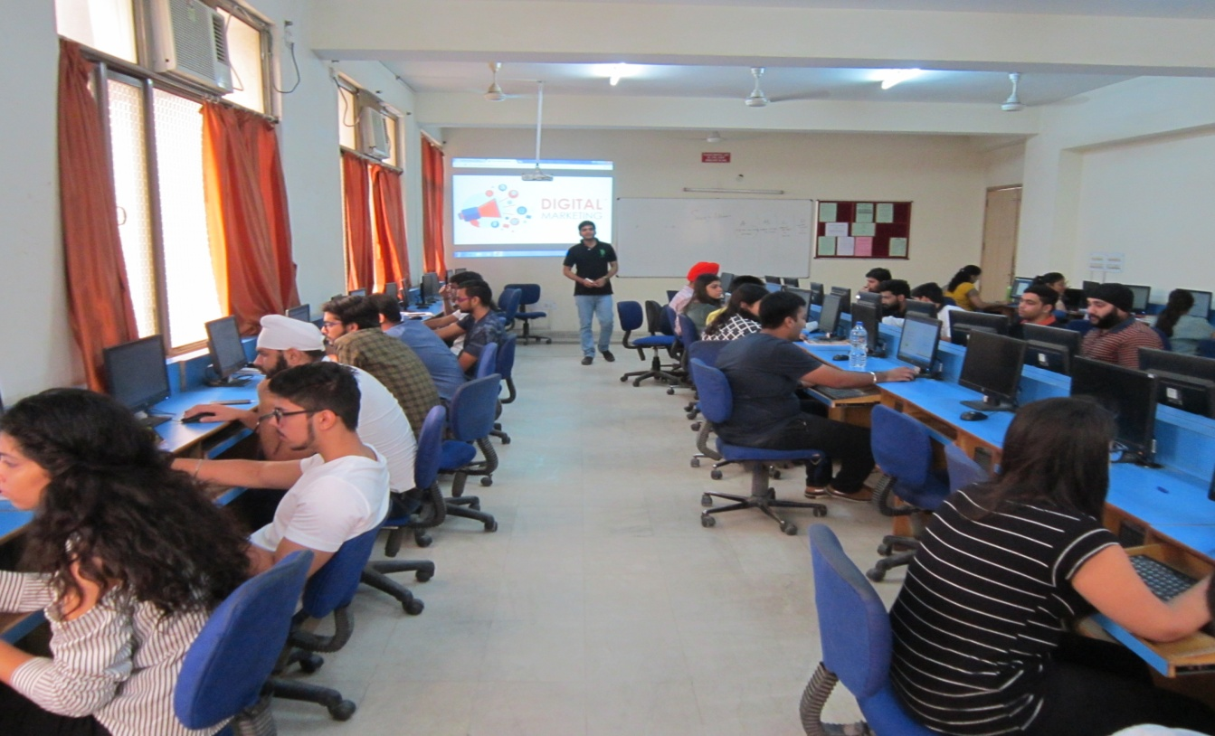
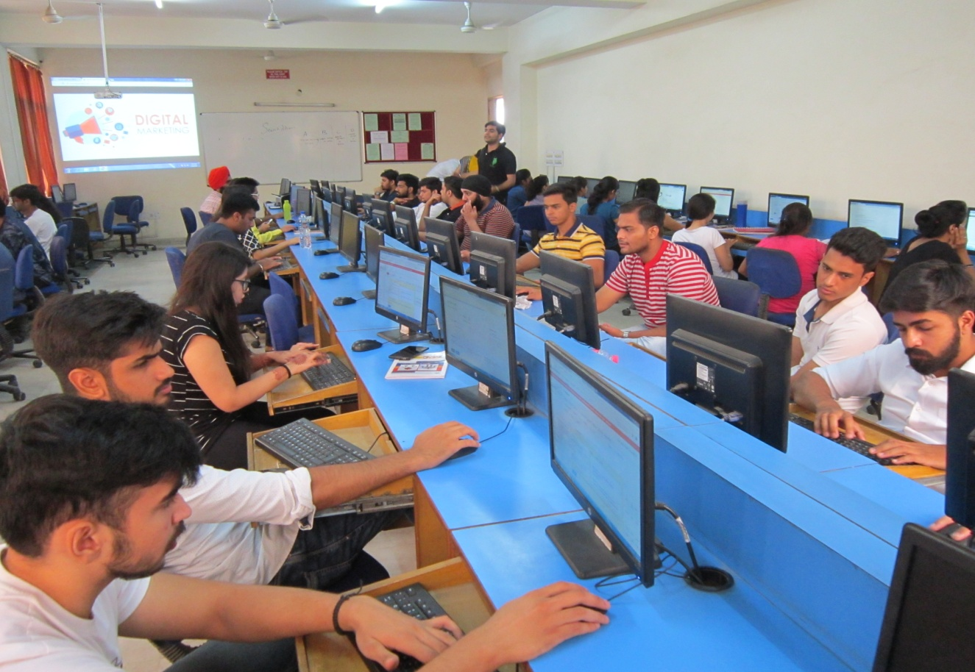
Overall digital marketing training was an informative and enriching experience for students. The students were very satisfied with the training. At the end of the training, students were given certificates.

Coordinator Director
Dr. Renu Sharma Prof. (Dr.) C. P. Chawla

